Yogurt Parfait

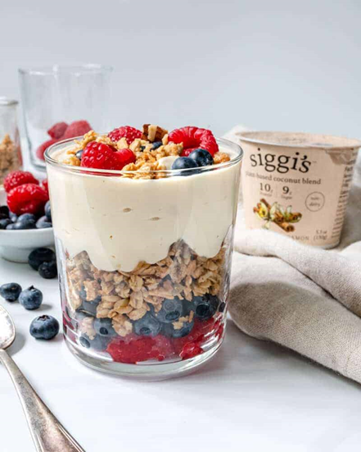

|  |
| --- |
| Ingredients With Measurements  * ¼ cup of fresh raspberries      * ⅓ cup of granola * 1 5.3-ounce cup of Siggi’s plant-based coconut blend yogurt |

|  |
| --- |
| Recipe In a short glass, add the blueberries and raspberries. Then, layer on the granola, followed by Siggi’s plant-based coconut blend yogurt.  Garnish with extra berries and granola. |

|  |  |  |  |
| --- | --- | --- | --- |
| |  |  | | --- | --- | | Raspberries | Granola | | Plant-Based Yogurt |  Ingredients Without Measurements |